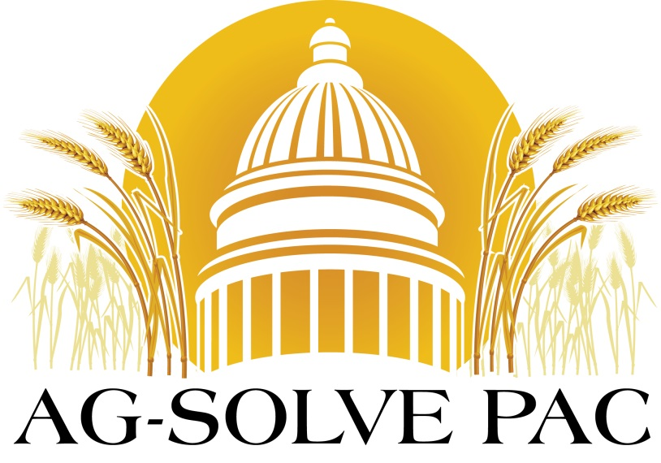
AG-SOLVE PAC is hosting its third annual live and silent auction. Contributions to AG-SOLVE allow IFCA to lobby effectively by making it possible to attend legislative fundraisers to support lawmakers who in turn support the agricultural input industry. AG-SLOVE also attends events to get to know urban legislators who are not familiar with the agribusiness industry. These events give IFCA direct access to legislators and enable us to develop stronger relationships with them.
2020 AG-SOLVE PAC Auction Items
Live Auction Items
Where: Tuesday at 3:30 pm on the trade show floor
Golf Cart – Altorfer
100 Hours of Rental on John Deere Tractor(9520R or 8370R) for Spring or Fall of 2020 – AHW John Deere
Two Tickets to Kenny Chesney at Soldier Field in Chicago, July 25 -BASF
Superior Regal 36 Gun Safe - Corteva
Taurus Judge Hand Gun– Dultmeier Sales
Traeger Grill – HarBrand Inc.
Golf Package for 4 at John Deere’s TPC Deere Run PGA golf course – Helena Chemical
Full Internal and External Tank Inspection – Heartland Tank
Raven VSN Visual Guidance System - Jenner
John Deere 6,000 Watt Generator - Martin Sullivan John Deere
Blackhawk Tickets – Nutrien
Browning Citori White Lighting – Nutrien
Benelli Super Black Eagle 3 Shot Gun – Syngenta
4 Cubs vs Cardinal Tickets July 26 – Syngenta
Metal American Flag - Syngenta
2 Tickets for Ron White in Springfield on March 12 (Row 4) – Yargus Manufacturing, Inc.
Original BIG N Metal Sign – AG-SOLVE

Silent Auction Items
Where: to the right of the main entrance of the Trade Room Floor
Tool Set – Adams Fertilizer Equipment
Dick’s Sporting Good Gift Cards – Agrian
1/32 RoGator RG1300 Toy - Altorfer
Stihl Chain Saw -AMVAC
Yeti Cooler - BASF
Stihl Handheld Leaf Blower – Brandt
Stihl Weed Eater – Brandt
Apple AirPods Pro - CHS
American Flag Flown over the U.S. Capitol – CropLife America
Yeti Cooler - Doyle
Golf Driver – Granite City Terminal
Yeti Rambler Tumbler - Koch
2020 Indy 500 Tickets - Marcus Construction
John Deere Pedal Tractor – Sloans
6 Tickets Dodgers vs Cubs, August 17th – Mosaic
Golf Bag - Mosaic
Three Bottles of Alpha Omega Proprietary Red Wine– Donnie Taylor
Aero Garden - Scott’s Miracle Gro
Arlo Security Cameras - Rosen’s
Oakley Flak Jacket Sunglasses – Squibb Taylor
¾ Cordless Impact Drive – The Equity
DC Gift Package – The Fertilizer Institute
IPAD - Winfield United

We want to thank all the individuals and companies who have stepped up to pledge and provide auction donations for this year’s event. Our successful event depends on your support! If you’d like to show your support, please contact K.J. Johnson at IFCA: kj@ifca.com

