## Single Day Collection Sites

**AM** Site hours are 9 a.m. to 11 a.m.

# PM Site hours are 1 p.m. to 3 p.m.

**\*\*\***  Site hours are 8 a.m. to 10 a.m.

**Date, Time Location Contact**

07/17 **PM** Southern FS Ryan Moss

Pulaski Pulaski (618) 845-3333

07/18 **\*\*\*** Bockhorn Ag, Inc. Justin Bockhorn

Randolph Sparta (618) 443-3905

07/18 **PM** Gateway FS Tim Keller

Monroe Waterloo (618) 939-8237

07/19 **AM** Nutrien Ag Sol, Inc. Jeff Haas

Clinton New Baden (618) 588-3525

07/19 **PM** Irvington Elevator Co Steve Seidel

Washington Irvington (618) 249-6206

07/22 **AM** Effingham Equity Andy Meinhart

Effingham Montrose (217) 342-3123

07/22 **PM** Nutrien Ag Sol, Inc. Randy Goodman

Fayette Vandalia (618) 283-1263

07/23 **AM** M & M Service Co Brian McKinney

Macoupin Girard (217) 627-2151

07/23 **PM** Effingham Equity Andy Meinhart

Christian Pana (217) 342-3123

07/24 **AM** Wabash Valley Srv Co Kent Ochs

Wayne Ellery 618-516-1697

07/24 **PM** Southern FS Jeff Brown

Franklin Mulkeytown (618) 724-2454

07/25 **AM** Prairieland FS, Inc. Chuck Ranson

Menard Greenview (217) 968-2282

07/25 **PM** Sunrise FS Zach Witherell

Cass Virginia (217) 836-0763

07/26 **AM** United Prairie, LLC Greg Cahill

Champaign Tolono (217) 480-7142

07/26 **PM** Nutrien Ag Sol, Inc. Todd Miller

Iroquois Onarga (815) 268-4428

07/29 **AM** Chem-Gro, Inc. Todd Nelson

Hancock Bowen (217) 842-5514

07/29 **PM** Nutrien Ag Sol, Inc. Travis Weaver

McDonough Blandinsville (309) 652-3694

07/30 **AM** Prairieland FS, Inc. Derek Prather

Schuyler Rushville (217) 322-2028

07/30 **PM** West Central FS Brian McMillen

Warren Ormonde (309) 255-5102

07/31 **AM** Earlybird Feed & Fert Karmon Gudeman

Tazewell Deer Creek (309) 620-1440

07/31 **PM** Ag-land FS, Inc. Jarret Summers

Peoria Hanna City (309) 565-4315

08/01 **AM** Chebanse Ag Dean Schafer

Kankakee Chebanse (815) 697-2392

08/01 **PM** Nutrien Ag Sol, Inc. Eric Green

Livingston Saunemin (815) 832-4491

08/02 **AM** Grainco FS, Inc. Albert Gutierrez

LaSalle Lostant (815) 368-3215

08/02 **PM** Helena Agri Entprs. Steve Miller

Woodford Toluca (815) 452-2377

08/05 **AM** Helena Agri Entprs. Gary Hopkins

DeKalb Kirkland (815) 522-3251

08/05 **PM** CHS Inc. Paul Ramm

Kane Maple Park (630) 247-8882

08/06 **AM** Conserv FS, Inc. Brett Wolter

McHenry Marengo (815) 568-7211

08/06 **PM** Conserv FS, Inc. Mike Webb

Winnebago Rockford (815) 703-4612

08/07 **AM** Pearl City Elev., Inc. Lucas Hagemann Stephenson Dakota (815) 541-8642

08/07 **PM** Carroll Srv Co. Riley Warnken

Carroll Milledgeville (815) 225-7101

### Permanent Collection Sites

Permanent collection sites are able to accept containers throughout the year. Before dropping off containers, call to ensure the facility will be open.

##### County Location Contact

Pike Logan Agri Srv. Inc. Troy Kennedy

Griggsville, IL 217-833-2375

Lawrence Klein Flying Serv. Ryan Klein

Lawrenceville, IL 812-890-6685

White Klein Flying Serv. Bri Klein

Carmi, IL 812-890-8605

### Sponsors

The Illinois Department of Agriculture sponsors the program in conjunction with the Agriculture Container Recycling Council; GROWMARK, Inc.; the Illinois Fertilizer and Chemical Association; G. Phillips and Sons, LLC; the Farm Bureau; and the U of I Extension Service.

###### **Acceptable Containers**

The program accepts only clean, dry high

density polyethylene (HDPE) #2, intermediate bulk and mini-bulk plastic agrichemical containers. All metal, fittings, caps, labels, booklets and foil seals must be removed. Please contact the IFCA, your local agri-chemical facility or the Department of Agriculture for more detailed instructions regarding the preparation of jugs, drums, intermediate bulk containers and mini-bulk containers.

### Container Rinsing

**To pressure rinse:**

Empty the pesticide into the spray tank and let the container drain for at least 30 seconds. Continue holding the container upside down, puncture the bottom, insert the nozzle, and rinse for the length of time recommended by the manufacturer, usually 30 seconds.

**To triple rinse:**

Empty the pesticide into the spray tank and let the container drain for at least 30 seconds.

Fill the container with water or rinse solution.

Place the lid securely on the container. Swirl

the container to thoroughly rinse all inside

surfaces.

Remove the lid, pour the rinsate into the

sprayer tank, and let the container drain for at least 30 seconds.

Repeat the above rinsing and draining steps at least two more times. Additional rinsing may be necessary to ensure containers are clean.

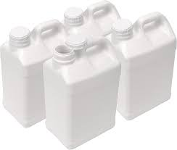

Illinois Department of Agriculture

Bureau of Environmental Programs

Illinois State Fairgrounds

P.O. Box 19281

Springfield, IL 62794-9281

Phone: 217-785-2427

TDD: 217-524-6858

Pesticide Hotline: 800-641-3934

Website: [www.agr.state.il.us](http://www.agr.state.il.us)

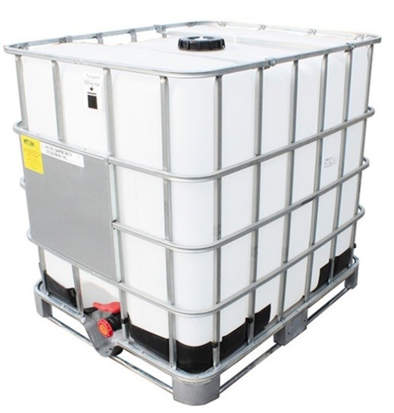

All other mini bulk containers 1 foot sq. pieces. No metal, fitting, or valves.

Cut into separate top, bottom, and sides. No metal, fittings, or valves.



2024

Pesticide

Container

Recycling

Program



