Single Day Collection Sites
AM Site hours are 9 a.m. to 11 a.m.

PM Site hours are 1 p.m. to 3 p.m.
*** Site hours are 8 a.m. to 10 a.m.
Date, Time Location Contact
07/17 PM Southern FS Ryan Moss
Pulaski Pulaski (618) 845-3333

07/18 *** Bockhorn Ag, Inc. Justin Bockhorn
Randolph Sparta (618) 443-3905

07/18 PM Gateway FS Tim Keller
Monroe Waterloo (618) 939-8237

07/19 AM Nutrien Ag Sol, Inc. Jeff Haas
Clinton New Baden (618) 588-3525

07/19 PM Irvington Elevator Co Steve Seidel
Washington Irvington (618) 249-6206

07/22 AM Effingham Equity Andy Meinhart
Effingham Montrose (217) 342-3123

07/22 PM Nutrien Ag Sol, Inc. Randy Goodman
Fayette Vandalia (618) 283-1263

07/23 AM M & M Service Co Brian McKinney
Macoupin Girard (217) 627-2151

07/23 PM Effingham Equity Andy Meinhart
Christian Pana (217) 342-3123

07/24 AM Wabash Valley Srv Co Kent Ochs
Wayne Ellery 618-516-1697

07/24 PM Southern FS Jeff Brown
Franklin Mulkeytown (618) 724-2454

07/25 AM Prairieland FS, Inc. Chuck Ranson
Menard Greenview (217) 968-2282

07/25 PM Sunrise FS Zach Witherell
Cass Virginia (217) 836-0763

07/26 AM United Prairie, LLC Greg Cahill
Champaign Tolono (217) 480-7142
07/26 PM Nutrien Ag Sol, Inc. Todd Miller
Iroquois Onarga (815) 268-4428

07/29 AM Chem-Gro, Inc. Todd Nelson
Hancock Bowen (217) 842-5514

07/29 PM Nutrien Ag Sol, Inc. Travis Weaver
McDonough Blandinsville (309) 652-3694

07/30 AM Prairieland FS, Inc. Derek Prather
Schuyler Rushville (217) 322-2028

07/30 PM West Central FS Brian McMillen
Warren Ormonde (309) 255-5102

07/31 AM Earlybird Feed & Fert Karmon Gudeman
Tazewell Deer Creek (309) 620-1440

07/31 PM Ag-land FS, Inc. Jarret Summers
Peoria Hanna City (309) 565-4315

08/01 AM Chebanse Ag Dean Schafer
Kankakee Chebanse (815) 697-2392

08/01 PM Nutrien Ag Sol, Inc. Eric Green
Livingston Saunemin (815) 832-4491

08/02 AM Grainco FS, Inc. Albert Gutierrez
LaSalle Lostant (815) 368-3215

08/02 PM Helena Agri Entprs. Steve Miller
Woodford Toluca (815) 452-2377

08/05 AM Helena Agri Entprs. Gary Hopkins
DeKalb Kirkland (815) 522-3251

08/05 PM CHS Inc. Paul Ramm
Kane Maple Park (630) 247-8882

08/06 AM Conserv FS, Inc. Brett Wolter
McHenry Marengo (815) 568-7211

08/06 PM Conserv FS, Inc. Mike Webb
Winnebago Rockford (815) 703-4612

08/07 AM Pearl City Elev., Inc. Lucas Hagemann Stephenson Dakota (815) 541-8642

08/07 PM Carroll Srv Co. Riley Warnken
Carroll Milledgeville (815) 225-7101

Permanent Collection Sites
Permanent collection sites are able to accept containers throughout the year. Before dropping off containers, call to ensure the facility will be open.

County Location Contact

Pike Logan Agri Srv. Inc. Troy Kennedy
Griggsville, IL 217-833-2375

Lawrence Klein Flying Serv. Ryan Klein
Lawrenceville, IL 812-890-6685

White Klein Flying Serv. Bri Klein
Carmi, IL 812-890-8605

Sponsors
The Illinois Department of Agriculture sponsors the program in conjunction with the Agriculture Container Recycling Council; GROWMARK, Inc.; the Illinois Fertilizer and Chemical Association; G. Phillips and Sons, LLC; the Farm Bureau; and the U of I Extension Service.

Acceptable Containers
The program accepts only clean, dry high
density polyethylene (HDPE) #2, intermediate bulk and mini-bulk plastic agrichemical containers. All metal, fittings, caps, labels, booklets and foil seals must be removed. Please contact the IFCA, your local agri-chemical facility or the Department of Agriculture for more detailed instructions regarding the preparation of jugs, drums, intermediate bulk containers and mini-bulk containers.

Container Rinsing

To pressure rinse:

Empty the pesticide into the spray tank and let the container drain for at least 30 seconds. Continue holding the container upside down, puncture the bottom, insert the nozzle, and rinse for the length of time recommended by the manufacturer, usually 30 seconds.

To triple rinse:

Empty the pesticide into the spray tank and let the container drain for at least 30 seconds.

Fill the container with water or rinse solution.

Place the lid securely on the container. Swirl
the container to thoroughly rinse all inside
surfaces.

Remove the lid, pour the rinsate into the
sprayer tank, and let the container drain for at least 30 seconds.

Repeat the above rinsing and draining steps at least two more times. Additional rinsing may be necessary to ensure containers are clean.

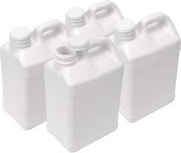

Illinois Department of Agriculture
Bureau of Environmental Programs
Illinois State Fairgrounds
P.O. Box 19281
Springfield, IL 62794-9281
Phone: 217-785-2427
TDD: 217-524-6858
Pesticide Hotline: 800-641-3934
Website: www.agr.state.il.us

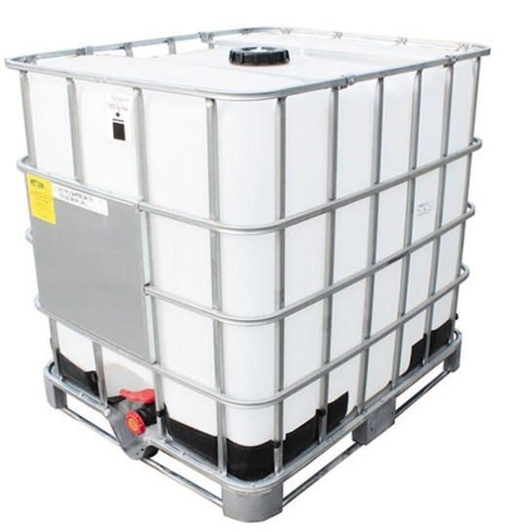
All other mini bulk containers 1 foot sq. pieces. No metal, fitting, or valves.
Cut into separate top, bottom, and sides. No metal, fittings, or valves.

2024
Pesticide
Container
Recycling
Program



